

**NAME =Imtiaz ali**

**COURSE=Web technology**

**REG NO =BS3990**

**Submitted to=Sir Afaq**

**(a) Basic Structure of an HTML5 Document**

<!DOCTYPE html>

<html>

<head>

<title>My Webpage</title>

</head>

<body>

<h1>Welcome to HTML5</h1>

</body>

</html>

**Explanation of major tags:**

* <!DOCTYPE html> → Defines the document type as HTML5.
* <html> → Root element that contains all HTML content.
* <head> → Holds metadata like title, CSS, scripts, and links.
* <title> → Specifies the title shown on the browser tab.
* <body> → Contains visible webpage content like text, images, and links.

**(b) Difference between <div> and <span>**

| **Tag** | **Type** | **Usage** | **Example** |
| --- | --- | --- | --- |
| <div> | Block-level element | Used for grouping **large sections** of content | <div><p>Paragraph inside a div</p></div> |
| <span> | Inline element | Used for styling **small parts** of text | <p>This is <span style="color:red;">important</span> text.</p> |

**Q.2: CSS Concepts & Selectors**

**(a) Types of Selectors (1.5 Marks)**

| **Selector** | **Syntax** | **Example** | **Description** |
| --- | --- | --- | --- |
| **Element Selector** | tagname {} | p { color: blue; } | Styles all <p> elements |
| **Class Selector** | .classname {} | .box { background: red; } | Styles elements having that class |
| **ID Selector** | #idname {} | #header { font-size: 20px; } | Styles a single unique element with that ID |

**(b) Difference between Display Types**

| **Property** | **Description** | **Example Behavior** |
| --- | --- | --- |
| display: inline; | Elements appear **side by side**, cannot set width/height | <span> |
| display: block; | Starts on a **new line**, takes full width | <div>, <p> |
| display: inline-block; | Appears **inline** but allows setting **width & height** | Used for nav buttons or boxes in one line |

**Q.3: Code Output & Positioning**

**Given Code:**

<div id="box1"></div>

<div id="box2"></div>

<div id="box3"></div>

**(a) Number and Colors of Boxes**

✅ **Three boxes** will appear.

* **Box 1:** lightcoral
* **Box 2:** lightgreen
* **Box 3:** lightcoral
* 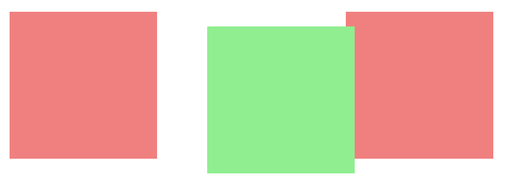

**(b) Position of the Second Box (#box2)**

Box 2 is **moved 10px down and 20px right** from its normal position, but still takes up its original space in the layout.

**(c) Purpose of position: relative;**

It allows an element to be **moved slightly** from its normal position **without affecting other elements**. Useful for small shifts or adding positioned child elements.

**Q.4: Flexbox Layout**

**(a) What is Flexbox and Why Used? (1 Mark)**

**Flexbox (Flexible Box Layout)** is a CSS layout model used to **arrange elements in a flexible and responsive manner**.

**Advantages:**

1. Easy to align items horizontally or vertically.
2. Automatically adjusts layout for different screen sizes.

**(b) Predicted Layout/Output (2.5 Marks)**

**Code Summary:**

<div class="container">

<div class="item">Box 1</div>

<div class="item">Box 2</div>

<div class="item">Box 3</div>

</div>

**CSS Behavior:**

* The container uses display: flex; → all items arranged **in one horizontal row**.
* justify-content: space-between; → equal space between boxes.
* Each box has a **steelblue background**, **white text**, and **10px padding**.
* Background of container = **lightgray**.

**Final Output Description:**  
Three rectangular boxes (Box 1, Box 2, Box 3) appear in one row — aligned with **space between them**, having **white text on steelblue boxes**, inside a **lightgray container**.



**Q.5: Bootstrap**

**(a) Two Ways to Include Bootstrap**

1. **Using CDN (Online Link):**

<link href="https://cdn.jsdelivr.net/npm/bootstrap@5.3.0/dist/css/bootstrap.min.css" rel="stylesheet">

1. **Using Local Files:**

<link href="css/bootstrap.min.css" rel="stylesheet">

<script src="js/bootstrap.min.js"></script>

**(b) Output of the Buttons**

<button class="btn btn-primary">Login</button>

<button class="btn btn-danger">Delete</button>

**Visible Output:**

* “**Login**” → Blue button (Primary style).
* “**Delete**” → Red button (Danger style).  
  Both styled with Bootstrap’s default padding, rounded edges, and hover effects.